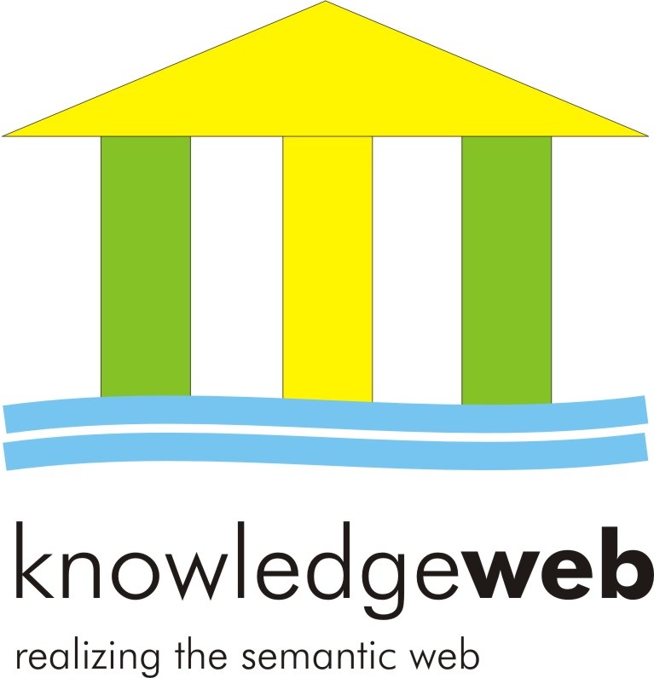

D 4.5.3-v2 Gender Action Plan and Public Engagement Activities

Coordinator: Carole Goble (UoM)

Contributions from
Yeliz Yesilada (UoM), Asunción Gómez-Pérez (UPM),
York Sure (UKARL), Jörg Diederich (L3S)

Abstract.
EU-IST Network of Excellence (NoE) IST-2004-507482 KWEB
Deliverable D4.5.3v2 (WP4.5)
An assessment of the gender and public engagement considerations of Knowledge Web is made. Statistics have been gathered on gender ratios over a range of metrics and public engagement activities. Revised recommendations for monitoring gender issues and public engagement activities are proposed.

Document Identifier: | KWEB/2008/D4.5.3/v2.0
Class Deliverable: | KWEB EU-IST-2004-507482
Version: | V2.0
Date: | January 12 2008
State: | Final
Distribution: | Public
Knowledge Web Consortium

This document is part of a research project funded by the IST Programme of the Commission of the European Communities as project number IST-2004-507482.
University of Innsbruck (UIBK) – Coordinator  Institute of Computer Science,  Technikerstrasse 13  A-6020 Innsbruck  Austria  Contact person: Dieter Fensel  E-mail address: dieter.fensel@uibk.ac.at | École Polythechnique Fédérale de Lausanne (EPFL)  Computer Science Department  Swiss Federal Institute of Technology  IN (Ecublens), CH-1015 Lausanne.  Switzerland  Contact person: Boi Faltings  E-mail address: boi.faltings@epfl.ch
France Telecom (FT)  4 Rue du Clos Courtel  35512 Cesson Sévigné  France. PO Box 91226  Contact person : Alain Leger  E-mail address: alain.leger@rd.francetelecom.com | Freie Universität Berlin (FU Berlin)  Takustrasse, 9  14195 Berlin  Germany  Contact person: Robert Tolksdorf  E-mail address: tolk@inf.fu-berlin.de
Free University of Bozen-Bolzano (FUB)  Piazza Domenicani 3  39100 Bolzano  Italy  Contact person: Enrico Franconi  E-mail address: franconi@inf.unibz.it | Institut National de Recherche en Informatique et en Automatique (INRIA)  ZIRST - 655 avenue de l'Europe - Montbonnot Saint Martin  38334 Saint-Ismier  France  Contact person: Jérôme Euzenat  E-mail address: Jerome.Euzenat@inrialpes.fr
Centre for Research and Technology Hellas / Informatics and Telematics Institute (ITI-CERTH)  1st km Thermi – Panorama road  57001 Thermi-Thessaloniki  Greece. Po Box 361  Contact person: Michael G. Strintzis  E-mail address: strintzi@iti.gr | Learning Lab Lower Saxony (L3S)  Expo Plaza 1  30539 Hannover  Germany  Contact person: Wolfgang Nejdl  E-mail address: nejdl@learninglab.de
National University of Ireland Galway (NUIG)  National University of Ireland  Science and Technology Building  University Road  Galway  Ireland  Contact person: Christoph Bussler  E-mail address: chris.bussler@deri.ie | The Open University (OU)  Knowledge Media Institute  The Open University  Milton Keynes, MK7 6AA  United Kingdom.  Contact person: Enrico Motta  E-mail address: e.motta@open.ac.uk
Universidad Politécnica de Madrid (UPM)  Campus de Montegancedo sn  28660 Boadilla del Monte  Spain  Contact person: Asunción Gómez Pérez  E-mail address: asun@fi.upm.es | University of Karlsruhe (UKARL)  Institut für Angewandte Informatik und Formale Beschreibungsverfahren – AIFB  Universität Karlsruhe  D-76128 Karlsruhe  Germany  Contact person: Rudi Studer  E-mail address: studer@aifb.uni-karlsruhe.de
University of Liverpool (UniLiv)  Chadwick Building, Peach Street  L697ZF Liverpool  United Kingdom  Contact person: Michael Wooldridge  E-mail address: M.J.Wooldridge@csc.liv.ac.uk | University of Manchester (UoM)  Room 2.32. Kilburn Building, Department of Computer Science, University of Manchester, Oxford Road  Manchester, M13 9PL  United Kingdom  Contact person: Carole Goble  E-mail address: carole@cs.man.ac.uk
University of Sheffield (USFD)  Regent Court, 211 Portobello street  S14DP Sheffield  United Kingdom  Contact person: Hamish Cunningham  E-mail address: Hamish@dcs.shef.ac.uk | University of Trento (UniTn)  Via Sommarive 14  38050 Trento  Italy  Contact person: Fausto Giunchiglia  E-mail address: fausto@dit.unitn.it
Vrije Universiteit Amsterdam (VUA)  De Boelelaan 1081a  1081HV. Amsterdam  The Netherlands  Contact person: Frank van Harmelen  E-mail address: Frank.van.Harmelen@cs.vu.nl | Vrije Universiteit Brussel (VUB)  Pleinlaan 2, Building G10  1050 Brussels  Belgium  Contact person: Robert Meersman  E-mail address: robert.meersman@vub.ac.be

Work package participants

The following partners have taken an active part in the work leading to the elaboration of this document, even if they might not have directly contributed writing parts of this document:

University of Karlsruhe (UKARL)
University of Manchester (UoM)
Universidad Politécnica de Madrid (UPM)
University of Innsbruck (UIBK)
France Telecom (FT)
Institut National de Recherche en Informatique et en Automatique (INRIA)
Learning Lab Lower Saxony (L3S)
The Open University (OU)
University of Liverpool (UniLiv)
Vrije Universiteit Brussel (VUB)

Changes

Version | Date | Author | Changes
0.1 | 15-12-2007 | Yeliz Yesilada | Initial Draft
0.2 | 31-01-2008 | Asunción Gómez-Pérez | QA Comments
0.3 | 04-02-2008 | Yeliz Yesilada | QA Changes

Executive Summary

This report consists of the following two parts:

PART 1 – Gender Action Plan

Knowledge Web is not a gender specific project. However, gender is a relevant issue for the project since it will: contribute on different levels to an enhanced understanding of gender issues; promote the participation of women in scientific research, education and outreach to industry; and include gender expertise in its scientific team and management.
We observed the gender issues involved in Knowledge Web, gathered statistics on gender ratios over a range of metrics, and surveyed organisations, networks, and projects concerned with gender and ICT. Here we summarise achievements in 2005, 2006 and 2007. In summary, we have been successful in our management of resources and sponsoring, less so on mentoring.
  - Resources
- The network continues to allocate 0.7% of the Knowledge Web budget to support financial incentives for women to attend women and ICT conferences etc. In 2006, we sponsored two events: BCSWomen and Women@CL career development workshop and the crèche facility at the 15th International World Wide Web Conference (WWW2006). Hoppers@KWeb also provided scholarships to individuals to attend a number of events, which include: The Doctoral Consortium at ISWC 2006 and the Knowledge Web PhD Symposium 2006 (KWEPSY2006). In summary, in 2006 we have used 89% of the allocated budget. In 2007, we provided scholarships to individuals to attend a number of events, which include the Doctoral Consortium at ISWC 2007, the Knowledge Web PhD Symposium and the Fifth Summer School on Ontological Engineering and the Semantic Web (SSSW’07). In summary, in 2007 we have used the 80% of the allocated budget.
  - Targets for Participation
- Partners of the network are asked to aim for 30% participation of women in their organisations and make plans for this.
- At least one woman should participate in the decision making and management of the main goals related to the education, industry, research and management area. Although we have achieved this target in the management area, we did not achieve this in the other areas.
- Each area should aim for 30% participation in the work package business.
- The T-Rex exchange programme should positively discriminate in favour of women. The number of female participants declined in 2006 but kept the same in 2007.
- Every effort should be made to ensure an appropriate and representative gender balance in the organizing and programme committees of the meetings sponsored and supported by Knowledge Web.
  - Information and Support
- Knowledge Web should forge links with relevant women’s networks and projects, and attend or support women and IT events such as the Grace Hopper conferences. Therefore in 2006, we sponsored the career development workshop that accompanies WWW2006.
- In 2006, a Hoppers@KWeb portal was created by the University of Manchester and regularly updated and maintained. This portal was set up specifically for disseminating information, funding opportunities, networks, events, etc. A mailing list was also created for similar purposes. In 2007, we have continued to update the portal regularly and use the mailing list to disseminate relevant information to the female Knowledge Web participants.
  - Monitoring and Advice
- A Knowledge Web Gender Observatory, made up of Knowledge Web partners and external experts, has stalled, partly as it hasn’t been seen as a high priority and the work package has been monitoring activities.
- In 2006, the University of Manchester initiated the collaboration with the UK Resource Center for Women in Science, Engineering and Technology (UKRC) to set up a mentoring scheme. Relevant resources were published on the Hoppers@KWeb portal. This has faltered due to operational difficulties and priorities.

Hoppers@KWeb proved to be a successful activity, particularly in providing personal scholarships and sponsoring events/activities, and the Web portal proved to be a very useful resource for the members. Therefore, we are in discussion with other Network of Excellences to continue to this activity.

PART 2 – Public Engagement Activities

In this report we first present results of the email survey conducted in 2005 and 2006 among the Knowledge Web members. We then propose a number of suggestions to improve the information dissemination to public which include:
- Using the general public’s vocabulary for communication
- Publishing articles and blogging for general public
- Supporting/sponsoring events targeting general public
- A complete revision of the Knowledge Web web site to reveal the outcomes and results
- Engaging professional PR services through strategic alliances with other organizations such as WSRI and the SemTech Symposium.

Contents

Contents 8
PART 1 - Gender Action Plan 1
1.1 Background and Overview 1
1.2 Knowledge Web Gender Observatory 2
1.2.1 Hoppers@KWeb Portal 2
1.2.2 Statistical monitoring 2
1.2.3 Observatory Oversight Board 3
1.3 Knowledge Web Members Participation 4
1.3.1 Enabling and encouraging participation 4
1.3.2 Personal funding 4
1.3.3 Sponsoring Gender Issues Related Conferences and Workshops 7
1.3.4 Mixed management teams and decision making 7
1.3.5 New partners 8
1.4 Knowledge Web Members Support 8
1.4.1 Meetings and events 8
1.5 Mentoring 8
1.5.1 What is mentoring? 9
1.5.2 Roles of a Mentor & Mentee 9
1.5.3 Phases of the Mentoring Relationship 10
1.6 Promotion of Gender Awareness 10
1.7 Relevance of Knowledge Web to Women 10
1.8 Observatory Statistics 10
1.9 Organisations and Networks 20
1.10 International Events 21
PART 2 - PUBLIC ENGAGEMENT ACTIVITIES 22
1.1 Survey of Public Engagement Activities 22
1.1.1 Communications to other Computer Science communities 22
1.1.2 Communications to Professional User Communities 24
1.1.3 Lectures to Public 24
1.1.4 Communications to general Public 25
1.2 Recommendations in a Nutshell 25
1.2.1 Using the General Publics’ vocabulary for Communication 26
1.2.2 Publishing Articles for General Public 27
1.2.3 A web site for the Computing Public 27
1.2.4 Supporting/Sponsoring Events Targeting General Public 28
1.2.5 Blogging the General Public and Computer Public 28
1.2.6 Organising Events that Involve General Public 28
1.2.7 Professional PR and Strategic Alliances 28

PART 1 - Gender Action Plan

Background and Overview

Knowledge Web is not a gender specific project. However, gender is a relevant issue for the project since it should:
- contribute on different levels to an enhanced understanding of gender issues;
- promote the participation of women in scientific research, education and outreach to industry; and
- include gender expertise in its scientific team and management.

According to a study by the Research Foundation for Improving the Representation of Women in the Technology Workforce, the number of women obtaining Bachelor’s and Master’s degrees in computer science is declining since 1996. However, according to Nielsen NetRatings, 51.7 percent of active US Internet users are women. The figures for Europe vary between 30% and 50%, and are still climbing.
Despite established systems of democracy and liberal doctrines of equality of opportunity, educational and professional fields in the West remain highly gender-oriented. 1999-2000 data from the UK shows that women were 62% of university graduates in arts and humanities subjects, but made up only 25% of computer science, 22% of physics and 13% of engineering graduates during this period .
We identify four aspects relevant to Knowledge Web:
- Support of the women in the Knowledge Web network in their career development (recruitment, retention, participation, progression and promotion) within their home institutions or organisations. Chief mechanisms by these means we hope to create a mutually supportive community of women in Knowledge Web include:
  - the promotion of opportunities and information through a dedicated portal — Hoppers@KWeb (http://hoppers-kweb.cs.manchester.ac.uk/);
  - encouraging women to participate in the T-Rex exchange programme and the Summer School;
  - enabling women to participate in national and international women and Information and Communication Technology (ICT) meetings; and
  - the instigation of a women’s mentoring scheme across the network.
- Participation by women in Knowledge Web: monitoring and enabling participation by women (postgraduates, researchers, industrialists and faculty academics) in Knowledge Web management, meetings, and deliverables; and in ensuring an inclusive and positive environment for women, for example by adopting gender-neutral language in deliverables and selecting gender-neutral case studies.
- Promotion of gender awareness across the Knowledge Web network thorough quantitative and qualitative monitoring and gender awareness and career development workshops organised by specialists in the area. Gender awareness should propagate to the home institutions and organisations.
- Relevance of Knowledge Web to women as it affects their working, social and family lives. Mechanisms include forging links with women’s networks, and presentations at relevant meetings.
The chief means of building and disseminating statistical evidence, know-how and information is through a Knowledge Web Gender Observatory. The network allocates 0.7% of the Knowledge Web budget to support other financial incentives for women. Incentives include: to fund participation in network activities and events that the network sponsors; to fund participation in women events such as the Grace Hopper Conferences; and to fund the participation of external advisors in the Observatory subject to their availability.

Knowledge Web Gender Observatory
In D4.5.1 (version 1 and 2) we proposed the establishment of a Knowledge Web Gender Observatory as a means of gathering a wide view of Knowledge Web and its surroundings with respect to the impact on women. The Observatory is made up of a number of information dissemination and gathering activities and an oversight. The Observatory’s four activities – Support, Participation, Promotion and Relevance – were outlined in Section 1.

Hoppers@KWeb Portal
In 2006, an independent portal was created dedicated to the Hopper which comes from the “Hoppers” networks of women in ICT in the UK and USA. This portal was created, and revised and maintained by the University of Manchester. The name is a tribute to Grace Hopper, a female pioneer of computing. The Hoppers@KWeb portal carries announcements of events, and specific references to: women’s groups and networks; relevant initiatives and projects; funding opportunities for women; relevant publications; scientific and technological careers; and any other information the network thinks useful. Figure 1 shows a screenshot of the home page of this portal.

Statistical monitoring
A range of statistics for quantitative monitoring contribute to the Network’s metrics, and will inform the Observatory. These statistics are collected and published through the portal (http://hoppers-kweb.cs.manchester.ac.uk/statistics.html). Metrics include the gender ratios of:
- network members;
- exchanged network members;
- educational trainers and trainees at Summer Schools and similar events;
- educational trainees and trainees at Summer School and similar events;
- organizers and invited speakers for meetings (e.g., conferences and workshops) sponsored by Knowledge Web;
- participants in area meetings;
- authors’ of each deliverable.
The statistics of the network at 48 months are given in Section 1.8.
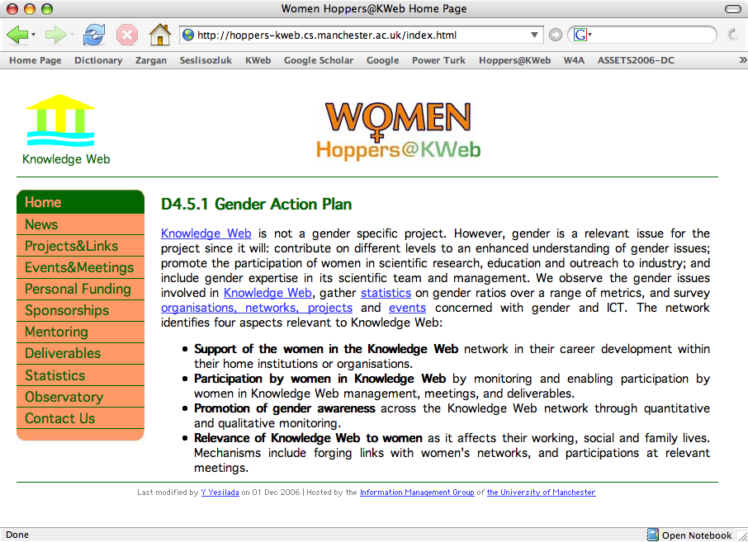
Figure 1 The home page of Hoppers@KWeb.

Observatory Oversight Board
To ensure that the issues are properly monitored and developed, it was planned that a small oversight committee will meet at plenary meetings every 6 months, supplemented by telecons. The committee is proposed to be composed of:
- Technical Director Guus Schreiber,
- Deputy Director Asunción Gómez-Pérez,
- Network administrator Alice Carpentier,
- Carole Goble,
- Yeliz Yesilada,
- External member.

In reality, this hasn’t happened – chiefly because Carole Goble hasn’t attended as many plenaries as in the past since she gave up the Research Directorship and took on other onerous commitments. Thus this Observatory Oversight Board needs to be revitalized or responsibility to just lie with the work package team.

Knowledge Web Members Participation
The issues regarding gender, and the action plans pertaining to gender, apply equally to all Work Packages and Areas.

Enabling and encouraging participation
- The Observatory monitors partners to ensure that the listed female participates of the network have attended meetings or have been given the opportunity to attend meetings.
- The T-Rex exchange programme of WP2.6 aims to achieve 30% participation in exchanges by women in the network. Figures for 2004, 2005 and 2006 are given in Table 7.2.
- The Hoppers@KWeb portal lists funding and networking opportunities for women (see http://hoppers-kweb.cs.manchester.ac.uk/funding.html).
- In 2006, two mailing lists were established within the Knowledge Web network: (1) for management (kweb-hoppers-mng@lists.manchester.ac.uk) which is used for receiving sponsorships and funding applications, particularly it is used for receiving applications for funding Doctoral Consortium for ISWC2006 and ISWC2007, KWEPSY2006, KWEPSY2007 and for other sponsorships; (2) for communication among female members (kweb-hoppers@lists.manchester.ac.uk), this list currently has 29 female members and has been used to announce information about the Website, gender issue related surveys and information about current events and activities. The latter mailing list was used and will be used to encourage participation and better communication between the women within the network.
- Work packages are encouraged to use modern virtual meeting technologies such as the Access Grid (http://www.accessgrid.org) and video conferencing for face-to-face meetings to limit the travel required and enable women (and men) with family commitments to fully participate. WP2.5 has used of the Access Grid technology for WP meetings.

Personal funding
To ensure the participation in Knowledge Web meetings of women who do not belong to partner institutes with funding, the project management team provides financial support for travel. We provide three types of funding:
- Meetings and Events Funding for KWeb Members:
The network proposes to enable members to participate in national and international women and Information and Communication Technology (ICT) meetings. Meetings are advertised on the Hoppers@KWeb events and meetings section (http://hoppers-kweb.cs.manchester.ac.uk/events.html) and members in the network are encouraged to apply for funds from their home institutions to attend these meetings. However, if they cannot get funding to attend these meetings from their home institution, Hoppers@KWeb aims to support their travel. Relevant application forms are available on the Hoppers@KWeb portal and applications are reviewed by our Observatory Oversight.
- Meetings and Events Funding for Non-Members
To ensure the participation in Knowledge Web meetings of women who do not belong to partner institutes with funding, the project management team provides financial support for travel. Relevant application forms are available on the Hoppers@KWeb portal and the Observatory Oversight Board assesses the applications by all participants. A positive discrimination policy for female applicants is practiced.
- Funded Events and Activities
Hoppers@KWeb also provides special funding to some particular events. In 2006 and 2007, special funding were provided for the following events:
- The Knowledge Web PhD Symposium 2006 (KWEPSY2006) (http://www.l3s.de/kweb/kwepsy2006/) Hoppers@KWeb funded seven female students to attend the KWEBSY2006. Table 1.1 shows the details of the provided funding. Three students were given partial funding as they were from an institution which is part of the KWEB network of excellence and they could also get funding from their own institution. Other four female students were given full funding and they were not from a member institution.
- The Doctoral Consortium (http://iswc2006.semanticweb.org/submissions/symposium.htm) at ISWC 2006 (http://iswc2006.semanticweb.org/), Hoppers@KWeb funded five students to attend this event. Table 1.2 shows the details of this funding. Two students were given partial funding and three students were given full funding.
- The Knowledge Web PhD Symposium 2007 (KWEPSY2007) (http://www.eswc2007.org/callforphdsymposium.cfm) Hoppers@KWeb funded five female students to attend the KWEBSY2007. Table 1.3 shows the details of the provided funding. One student was given partial funding as she is from an institution which is part of the KWEB network of excellence and she could also get funding from her own institution. Other four female students were given full funding and they were not from a member institution.
- The Doctoral Consortium (http://iswc2007.semanticweb.org/callfor/DoctoralConsortium.asp) at ISWC 2007 (http://iswc2007.semanticweb.org/) Hoppers@KWeb funded five students to attend this event. Table 1.4 shows the details of this funding. Three students were given full funding and one student was given partial funding.

Table 1.1 Scholarship Details for the KWEPSYS2006
Name | Affiliation | Kweb Member | Type
Loredana Laera | University of Liverpool | Yes | Partial
Maria (Marjike) Keet | Free University of Bozen - Bolzano | Yes | Partial
Malgorzata Mochol | Free University of Berlin | Yes | Partial
Miriam Fernandez | Universidad Autonoma de Madrid | No | Full
Agnieszka Lawrynowicz | Poznan University of Technology | No | Full
Muresan Ana-Maria | Babes-Bolyai University of Cluj-Napoca, Romani | No | Full
Dilek Tapucu | Ege University & Poitiers University (France) | No | Full

Name | Affiliation | Kweb member | Type
Harry Halpin | University of Edinburgh, UK | No | Partial
Cuii Tao | Brigham Young University, USA | No | Partial
Esther Kaufmann | University of Zurich, Department of Informatics, Switzerland | No | Full
Ozgu Can | Computer Engineering Department of Ege University, Turkey | No | full
Carolina Felicissimo | Pontifical Catholic University of Rio de Janeiro (PUC-Rio), Brazil | No | Full
Table 1.2 Scholarship Details for the DC at ISWC2006
Name | Affiliation | Kweb Member | Type
Anne Schlicht | Univesitat Mannheim | No | Full
Angela Fogarolli | University of Trento | Yes | Partial
Asma Ounnas | University of Southampton | No | Full
Eva Blomqvist | Jonkoping University | No | Full
Azzurra Ragone | Politecnico di Bari | No | Full
Table 1.3 Scholarship Details for the KWEPSYS2007

Name | Affiliation | Kweb member | Type
Ming Mao | University of Pittsburgh | No | Partial
Katharina Reinecke | University of Zurich | No | Full
Livia Predoiu | University of Manheim | Non-funded | Full
Ying Wang | Queen's University | No | Full
Table 1.4 Scholarship Details for the DC at ISWC 2007

Applications for all these personal funding are enabled through the portal and assessed by the Observatory Oversight Board. A positive discrimination policy for female applicants is practised. Since the European Commission funds the Knowledge Web project, students from European Union member countries also have higher priorities for this funding.
- Personal Funding
To ensure the participation in Knowledge Web meetings of women who do not belong to partner institutes with funding, Hoppers@KWeb provides financial support for travel. In 2007, Hoppers@KWeb funded one student to attend the Fifth Summer School on Ontological Engineering and the Semantic Web (SSSW'07) which was held in Cercedilla (Spain).

Sponsoring Gender Issues Related Conferences and Workshops
Hoppers@KWeb also supports events and activities that are related to gender issues (e.g., career development events, etc. – for more examples see http://hoppers-kweb.cs.manchester.ac.uk/events.html). Although Knowledge Web sponsors a range of technical meetings, conferences, workshops and events, we believe sponsoring events related to gender issues is important to increase the awareness of gender issues. Sponsorship applications are widely advertised on the Hoppers@KWeb portal (http://hoppers-kweb.cs.manchester.ac.uk/sponsorship.html). In 2006 Hoppers@KWeb successfully sponsored the following events:
- BCSWomen and Women@CL Career Development Workshop 2006 (http://www.bcs.org.uk/bcswomen/www2006workshop.htm), this workshop was organised in conjunction with the International WWW2006 Conference and Hoppers@KWeb sponsored the best poster award.
- The crèche facility at the 15th International World Wide Web Conference 2006 (WWW2006 - http://www2006.org/), this facility was fully sponsored by Hoppers@KWeb.

Mixed management teams and decision making
The network aims to ensure that a least one woman will participate in the decision making and management of the main goals related to the education, industry and research area, and that each area should aim for 30% participation in the work package business. In the first 36 months of Knowledge Web, the status is as follows.

- Industry Area: Two area directors: 100:0 male: female ratio. Six work packages: leaders 33:66 male:female ratio.
- Research Area: Two area directors: 100:0 male:female ratio. Six work packages: leaders 100:0 male:female ratio.
- Education Area: Two area directors: 100:0 male: female ratio. Three work packages: leaders 100:0 male:female ratio.
- Management Area: Two scientific vice directors: 50:50 male:female ratio. The scientific director and the project coordinator are male. Two of the three managing directors are female. Six work packages: leadership 50:50 male:female ratio.

The majority of the Research work package participants are male. Further statistics for 2004-2007 are given in Table 7.1. - 7.8.

New partners
New partners to the network are required to show that they will aim for 30% participation of women in their organisations. Partners that show a commitment to redressing the gender balance of the network will be given greater priority than those that do not.

Knowledge Web Members Support
The network aims to create a mutually supportive community of women in Knowledge Web. In addition to the promotion of opportunities and information through the Hoppers@KWeb portal, further specific actions are proposed.

Meetings and events
The network proposes to encourage women to participate in the T-Rex exchange programme and the Summer School. Disappointingly, the number of female participants in T-Rex declined in 2006; and kept the same in 2007. Although the numbers of female trainers decreased in 2006, the number of female trainees increased and kept the same in 2007. Female trainees, however, gradually increased since 2004 (see Table 7.3 and 7.4).

Mentoring
We are collaborating with the UK Resource Center for Women in Science, Engineering and Technology (UKRC) (http://www.mentorset.org.uk/) to set up a mentoring scheme. UKRC is funded by the DTI and European Social Fund since 2004. Its main mission is to promote the participation and position of women in science, engineering and technology, and it provides a range of services including networking, mentoring support, good practice guides for employers and media projects.
The main aim of Hoppers@KWeb Mentoring is to offer support and encouragement to women establishing their careers in Semantic Web. A mentor is a guide who can point you in the right direction, advise on career matters, and help you to overcome problems. Having a good mentor can be a short cut to success. A mentor should help you to believe in yourself and boost your confidence, should ask questions and challenge you, while providing guidance and encouragement. Mentoring is acknowledged as a key tool in personal development and empowerment.
We aim to connect women in Knowledge Web with mentors either within Knowledge Web or without who can offer advice and guidance about the issues important to them; mentors who can help with self-development, suggest networking opportunities and empower mentees to make their own decisions and turn these into actions.
In the process of setting up the mentoring scheme for KWeb, we started to create a number of resources for the Knowledge Web participants with the considerable help given to us by Samantha Haynes and Rachel Tobbell from UKRC.
This has proved to be hard to set in place for a number of reasons, including: cultural differences across the network; commitments from busy members of the network; and frankly, low prioritisation of the activity. In 2007 we should reflect on the need and desire for mentoring had how it can be realistically developed.

What is mentoring?
Mentoring could be described as follows:
- Off-line help by one person to another in making significant transitions in knowledge, work or thinking (David Clutterbuck & David Megginson, Techniques for Coaching and Mentoring, 2004).
- To support and encourage people to manage their own learning in order that they may maximise their potential, develop their skills, improve their performance and become the person they want to be (Eric Parsloe - Oxford School of Coaching and Mentoring).
- “I have learned what mentoring actually is: professional friend, partnership, a person who guides, listens and supports to enable you to get where you want to be” (A mentor on a UK Resource Centre Mentoring Programme).

Roles of a Mentor & Mentee

The following keywords could be used to describe Mentor: “Coach, Facilitator, Role model, Sounding board” and Mentee “Develops skills, Self-managed learner, Develops vision for career, Seeks advice & ideas”

What's in it for the mentor?

- Develops own skills;
- Satisfaction at seeing someone else grow;
- Opportunity to be challenged;
- Opportunity for reflection and validation of own experience/decisions;
- But not status, financial reward or ego-massage.

What's in it for the mentee?

- Source of advice and guidance;
- Reassurance / confidence;
- Personal reflective space;
- Source of challenge;
- Access to networks;
- Greater knowledge of sector;
- Career planning.

Phases of the Mentoring Relationship
Mentoring phases typically include the following, which are illustrated in Figure 3: Building rapport, setting direction, prograssion, maturation

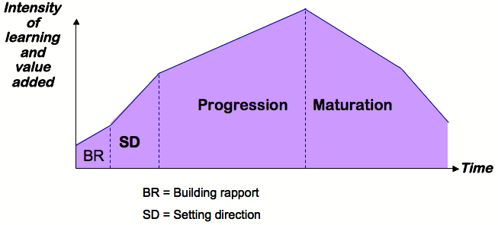
Figure 2 Diagram taken from Mentoring in Action, Megginson, Clutterbuck et al, 2nd Edition, Page 20, Kogan Page, 2006.

Promotion of Gender Awareness
Quantitative and qualitative monitoring by the Observatory will contribute to gender awareness throughout the network.

Relevance of Knowledge Web to Women
We encourage women to pursue a scientific, engineering or technological career by giving them access to the necessary resources, through linking them up to inspiring female scientific and technological networks, and in providing them with gender neutral tools and languages.
In the dissemination of Knowledge Web, we will ensure that part of the effort will be directed towards a female public and presented at several international women in computing organizations such as the Grace Hopper conference and workshops and conferences of the most relevant organizations of women and technology in Europe and the USA such as the ones mentioned above. Further suggestions will be made by the Observatory.

Observatory Statistics
Table 7.1 Gender distribution network partners of active participants as given on the Knowledge Web portal, Dec 2004-2007. Only 4 currently reach the target of 30% or more female participation.
Participant | Male | Female | % Female
UIBK | 8 | 4 | 33%
ITI-CERTH | 7 | 1 | 13%
FT | 8 | 0 | 0%
EPFL | 8 | 0 | 0%
LivUni | 3 | 2 | 40%
FUB | 7 | 1 | 13%
FU Berlin | 5 | 2 | 29%
INRIA | 8 | 2 | 20%
L3S | 4 | 2 | 33%
NUIG | 10 | 0 | 0%
UPM | 9 | 3 | 25%
OU | 4 | 0 | 0%
UKARL | 9 | 0 | 0%
VUA | 11 | 3 | 21%
UniTn | 10 | 2 | 17%
UoM | 12 | 5 | 29%
VUB | 3 | 0 | 0%
USFD | 3 | 2 | 40%
Total | 129 | 29 | 18%
Table 7.2 T-Rex Exchanges between network partners in 2004, 2005, 2006 and 2007 as given on the Knowledge Web Portal December 2007. The table shows %11 female ratio.
Start | End | Person | Sender | Host | Topic | Gen
16.01.2004 | 30.01.2004 | Ilya Zaihrayeu | UniTn | UIBK | Semantic heterogeneity | M
25.02.2004 | 16.04.2004 | M. Carmen Suarez-Figueroa | UPM | LivUni | Ontology Evaluation | F
04.06.2004 | 09.07.2004 | Angel Lopez Cima | UPM | OU | Kweb portal and MagPie integration | M
20.07.2004 | 20.08.2004 | Wolfgang Nejdl | L3S | EPFL | Semantic Web Query Evaluation in Distributed Environments | M
21.07.2004 | 15.09.2004 | Axel Polleres | UIBK | NUIG | Reasoning for Semantic Web Services in WSMO WSML | M
22.07.2004 | 30.09.2004 | Ruben Lara | UIBK | NUIG | Semantic Web Service discovery in WSMO | M
23.08.2004 | 03.09.2004 | Wolf Siberski | L3S | EPFL | Semantic Web Query Evaluation in Distributed Environments | M
30.08.2004 | 11.09.2004 | Holger Wache | VUA | UniTn | Ontology Modules and Contexts for Ontologies | M
13.09.2004 | 15.10.2004 | Marta Sabou | VUA | USFD | Extracting web-service ontologies using Natural Language Technologie | F
24.09.2004 | 15.10.2004 | Rafael Gonzalez Cabero | UPM | USouth | Adequacy of the SW technology for developing the AgentLink III portal | M
27.09.2004 | 27.01.2005 | Davide Guidi | FUB | OU | Web services and ontologies development and Integration of the Sesame architecture into OCML language | M
27.09.2004 | 1.10.2004 | Klaus Schild | FU Berlin | NUIG | RDF Model Theory | M
04.10.2004 | 06.10.2004 | Marta Sabou | VUA | UoM | Evaluation of Extracting web-service ontologies using Natural Language Technologies | F
06.10.2004 | 3.11.2004 | Pavel Shvaiko | UniTn | INRIA | Ontology Alignment | M
01.11.2004 | 31.12.2004 | Wolf Winkler | NUIG | UKARL | Ontology Versioning | M
22.11.2004 | 11.02.2005 | Christoph Tempich | UKARL | INESC-ID Lisabon | Ontology Engineering methodology | M
17.01.2005 | 11.02.2005 | Heiner Stuckenschmidt | UoM | L3S | Combining Semantic Web and Peer-to-peer Technologies to support inter-organizational information sharing | M
31.01.2005 | 13.02.2005 | Jeff Z. Pan | VUM | FUB | Querying databases with ontologies | M
16.02.2005 | 11.03.2005 | Wolf Siberski | L3S | VUA | Combining knowledge representation and information sharing infrastructures | M
14.03.2005 | 14.04.2006 | Raul Palma | UPM | UKARL | Oyster + Ontology Repository | M
04.04.2005 | 29.04.2005 | Knud Moller | NUIG | USFD | Scalability of Annotation Services | M
17.04.2005 | 30.04.2005 | Jeff Z. Pan | UoM | FUB | Querying ontologies and datatypes | M
25.04.2005 | 27.05.2005 | Marc Ehrig | UKARL | INRIA | Ontology Alignment | M
09.05.2005 | 27.05.2005 | Lyndon JB Nixon | FU Berlin | ITI-CERTH | Multimedia and Semantic Web technologies | M
22.05.2005 | 30.05.2005 | Jeff Z. Pan | UoM | ITI-CERTH | f-SI and f-SWRL | M
28.06.2005 | 08.07.2005 | Jos de Brujin | UIBK | FUB | Logical reconstruction of RDF | M
04.07.2005 | 16.07.2005 | Jeff Z. Pan | UoM | VUA | Anytime DL reasoning | M
25.07.2005 | 19.08.2005 | Jörg Diederich | L3S | OU | ASPL-2: The next version of the Advanced Platform for Learning | M
01.08.2005 | 19.08.2005 | Elena Paslaru Bontas | FUB | UKARL | Ontology Cost Estimation | F
24.08.2005 | 30.09.2005 | Mustafa Jarrar | VUB | FUB | Ontology Modularization | M
01.09.2005 | 30.09.2005 | Stefano Spaccapietra | EPFL | FUB | Temporal Logic and Conceptual Modeling of Temporal Data | M
03.11.2005 | 20.02.2006 | Max Völkel | UKARL | Deri Galway | SemVersion, Semantic Wikis for Personal KM | M
16.11.2005 | 16.11.2005 | Jeff Pan | Aberdeen | UoM | Integrating and Querying Parallel Leaf Shape Descriptions | M
27.03.2006 | 02.04.2006 | Wolf Siberski | L3S | Aberdeen | Querying the Semantic Web with Preferences | M
25.04.2006 | 24.05.2006 | Raúl Palma | UPM | UKARL | OMV/Oyster | M
16.6.2006 | 24.07.2006 | Andrei Tamilin | UniTn | Mannheim | Improving Automatically Created Mappings using Logical Reasoning | M
19.06.2006 | 20.08.2006 | Mikalai Yatskevich | UniTn | IBM | Information integration | M
24.06.2006 | 13.09.2006 | York Sure | UKARL | Stanford | Ontology Engineering | M
16.10.2006 | 30.04.2007 | Enrico Franconi | FUB | UNS (ARG), Otago (NZ), NICTA/UNSW (AUS) | Conceptual Modelling | M
01.02.2007 | 30.04.2007 | Raúl García-Castro | UPM | VA | Reasoners Benchmarking | M
06.02.2007 | 14.02.2007 | Giorgos Stoilos | ITI-CERTH | Aberdeen | Expressive querying | M
06.02.2007 | 06.03.2007 | Zharko Aleksovski | VA | OU | Ontology Matching | M
19.02.2007 | 28.02.2007 | Martin Dzbor | OU | L3S | Service interchange | M
26.02.2007 | 12.03.2007 | Loredana Laera | UniLiv | INRIA | Ontology Alignment | F
01.06.2007 | 15.07.2007 | Raul Palma | UPM | Poznan University | Web Services | M
07.09.2007 | 05.10.2007 | Raul Palma | UPM | UKARL | Propagation models | M
09.09.2007 | 19.09.2007 | Giorgos Stoilos | ITI-CERTH | Aberdeen | Query Answering | M
22.10.2007 | 02.11.2007 | Angel López-Cima | UPM | Innsbruck | KnowledgeWeb portal | M
 |  |  |  |  | Overall %F | 11
Table 7.3 Educational trainers at the 2004, 2005, 2006 and 2007 European Summer School on Ontological Engineering and the Semantic Web, Cercedilla, Spain.
Summer School | Dates | Tutors |  |  | Invited Speakers |  |  | Directors
Summer School | Dates | M | F | %Female | M | F | %Female | M | F | %Female
SSSW'04 | 19/07/2004-4/07/2004 | 5 | 1 | 17 | 5 | 0 | 0 | 2 | 1 | 33
SSSW'05 | 10/07/2005-6/07/2005 | 5 | 2 | 29 | 5 | 1 | 17 | 2 | 1 | 33
SSSW’06 | 15/07/2006-9/07/2006 | 5 | 1 | 17 | 5 | 0 | 0 | 3 | 1 | 25
SSSW’07 | 8/07/2007-14/07/2007 | 6 | 1 | 14 | 5 | 0 | 0 | 4 | 1 | 20

Table 7.4 Educational trainees at the 2004, 2005, 2006 and 2007 European Summer School on Ontological Engineering and the Semantic Web, Cercedilla, Spain.
Summer School | Male | Female | %Female
SSSW'04 | 41 | 15 | 27
SSSW'05 | 40 | 16 | 29
SSSW’06 | 33 | 17 | 34
SSSW’07 | 30 | 20 | 40

Table 7.5 Organization committee and invited speakers of the workshops organised by Knowledge Web in 2004-2007(? means figures are unavailable and – means there were no keynote or invited speakers).
Acronym | Title | Organization Committee |  |  | Invited/ Keynote  Speakers
Acronym | Title | M | F | %F | M | F | %F
EON2007 | 5th International EON Workshop on Evaluation of Ontologies and Ontology-based tools | 4 | 1 | 20 | 0 | 0 | 0
OOA2007 | Ontology-Based Competency Modeling Frameworks | 5 | 0 | 0 | - | - | -
BAST2007 | 1st European Workshop on Business added-value of semantic technologies | 1 | 1 | 50 | - | - | -
EON2006 | Evaluation of Ontologies for the Web (http://km.aifb.uni-karlsruhe.de/ws/eon2006) | 3 | 1 | 25 | - | - | -
DL2006 | International Workshop on Description Logics (http://dl.kr.org/dl2006/) | 2 | 1 | 33 | 2 | 0 | 0
KWEPSY2006 | KnowledgeWeb PhD Symposium 2006 (http://www.l3s.de/kweb/kwepsy2006) | 2 | 1 | 33 | - | - | -
STICA 06 | Semantic Technologies in Collaborative Applications (http://www.inf.fu-berlin.de/inst/ag-nbi/conf/STICA06/) | 2 | 1 | 33 | - | - | -
C&O-2006 | Contexts and Ontologies: Theory, Practice and Applications (http://www.c-and-o.net/) | 4 | 1 | 20 | 1 | 1 | 50
OnToContent06 | Workshop on Ontology content and evaluation in Enterprise (http://www.starlab.vub.ac.be/staff/mustafa/OnToContent06) | 4 | 0 | 0 | - | - | -
OM2006 | The ISWC'06 International Workshop on Ontology Matching (http://www.om2006.ontologymatching.org/) | 5 | 1 | 17 | 2 | 0 | 0
OWL-ED2006 | OWL: Experiences and Directions Workshop (http://owl-workshop.man.ac.uk/OWLWorkshop06.html) | 4 | 0 | 0 | - | - | -
SEMPS2006 | Semantic Enhanced Multimedia Presentation Systems (http://mmit.informatik.uni-oldenburg.de/SEMPS2006/) | 2 | 2 | 50 | 1 | 0 | 0
MTW2006 | Models of Trust for the Web (www.l3s.de/~olmedilla/events/MTW06_Workshop.html) | 2 | 1 | 33
BAOSW2005 | Building and Applying Ontologies for the Semantic Web (http://baosw.epia05.di.ubi.pt/) | 2 | 2 | 50 | 1 | 0 | 0
SWCASE2005 | Semantic Web Case Studies and Best Practices for eBusiness (http://nbi.inf.fu-berlin.de/conf/SWCASE05) | 3 | 0 | 0 | - | - | -
SWESE2005 | Semantic Web Enabled Software Engineering (http://www.mel.nist.gov/msid/conferences/SWESE/) | 3 | 1 | 25 | - | - | -
OWLED2005 | OWL Experiences and Directions (http://www.mindswap.org/2005/OWLWorkshop/) | 4 | 0 | 0 | - | - | -
IntOnt2005 | Integrating Ontologies (http://km.aifb.uni-karlsruhe.de/ws/intont2005) | 4 | 0 | 0 | - | - | -
Font2005 | Foundational Aspects of Ontologies (http://www.aifb.uni-karlsruhe.de/WBS/phi/FOnt2005/) | 3 | 0 | 0 | 1 | 0 | 0
WORM 2005 | The 3rd International Workshop on Regulatory Ontologies (http://www.starlab.vub.ac.be/staff/mustafa/WORM_2005.htm) | 5 | 0 | 0 | - | - | -
LWS2005 | Learning in Web Search (http://cosco.hiit.fi/search/learninginsearch05/) | 3 | 0 | 0 | 2 | 1 | 33
C&O2005 | Contexts and Ontologies: Theory, Practice and Applications (http://dit.unitn.it/~pavel/cando/) | 3 | 1 | 25 | 2 | 0 | 0
OntoP2P2005 | Ontologies in P2P Communities (http://www.kde.cs.uni-kassel.de/ws/ontop2p2005) | 3 | 0 | 0 | - | - | -
SFSW2005 | Scripting for the Semantic Web (http://www.semanticscripting.org/SFSW2005/) | 2 | 1 | 33 | - | - | -
UserSWeb | Workshop on End User Aspects of the Semantic Web (http://kmi.open.ac.uk/events/usersweb) | 2 | 1 | 33 | - | - | -
ESWC05_MSW | Multimedia and the Semantic Web (http://www.acemedia.org/ESWC2005_MSW) | 4 | 0 | 0 | 1 | 1 | 50
 | Interoperability of Web-Based Educational Systems at the WWW 2005 (http://www.l3s.de/~olmedilla/events/interoperability.html) | 3 | 0 | 0 | - | - | -
IKMTOOLS2005 | Workshop on Intelligent IT Tools for Knowledge Management Systems: Applicability, Usability, and Benefits (http://wm2005.iese.fraunhofer.de/workshop11-en.html) | 4 | 1 | 20 | - | - | -
CECC 2005 | Corporate Education Course Content (http://www.l3s.de/~diederich/cecc) | 1 | 1 | 50 | - | - | -
SWop2005 | Semantic Web Interoperability Workshop (http://kmi.open.ac.uk/events/SWOp) | 1 | 1 | 50 | - | - | -
OMAC2005 | Workshop on Ontology Modularization and Context (http://www.starlab.vub.ac.be/staff/mustafa/OMAC.htm) | 1 | 0 | 0 | - | - | -
ONS 2004 | Ontologies for Networked Systems (http://km.aifb.uni-karlsruhe.de/ws/ons2004) | 2 | 1 | 33 | - | - | -
EON 2004 | Evaluation of Ontology-based Tools (http://km.aifb.uni-karlsruhe.de/ws/eon2004) | 4 | 0 | 0 | - | - | -
MCN2004 | Meaning Coordination and Negotiation (http://dit.unitn.it/~bouquet/ISWC-04-MCN/) | 7 | 0 | 0 | - | - | -
SWS2004 | Semantic Web Services (http://www.ai.sri.com/SWS2004/organization.html) | 3 | 0 | 0 | - | - | -
WORM 2004 | Workshop on Regulatory Ontologies (http://www.starlab.vub.ac.be/staff/mustafa/WORM_2004.htm) | 2 | 0 | 0 | 1 | 0 | 0
OMAC2004 | Workshop On Ontology Modularization and Context (http://www.starlab.vub.ac.be/staff/mustafa/OMAC.htm) | 1 | 0 | 0 | - | - | -
SWEB 2004 | Semantic Web technologies in Electronic Business (http://sweb.xml-clearinghouse.de) | 3 | 0 | 0 | ? | ? | ?
SWSDN 2004 | Semantic Web Services and Dynamic Networks (http://km.aifb.uni-karlsruhe.de/ws/swsdn2004) | 3 | 0 | 0 | - | - | -
SIM2004 | Semantic Intelligent Middleware for the Weband the Grid (http://www.intelligence.tuc.gr/sim2004) | 4 | 2 | 33 | - | - | -
SWWC2004 | Workshop on Application of Semantic Web Technologies to Web Communities (http://www.deri.at/events/meetings/swpECAI04/) | 5 | 1 | 17 | 1 | 0 | 0
OLP2004 | Ontology Learning and Population (http://olp.dfki.de/ecai04/cfp.htm) | 3 | 0 | 0 | - | - | -
MSW2004 | Mining for and from the Semantic Web (http://km.aifb.uni-karlsruhe.de/ws/msmw2004) | 2 | 1 | 33 | ? | ? | ?
P2PKM2004 | Peer-to-Peer Knowledge Management (http://www.p2pkm.org) | 2 | 0 | 0 | 2 | 0 | 0

Table 7.6 Organization committee and invited speakers of the conferences organised by Knowledge Web in 2004-2007 (? means figures are unavailable and – means there were no keynote or invited speakers).
Acronym | Title | Organisation Committee |  |  | Invited Speakers
Acronym | Title | M | F | %F | M | F | %F
ESWS 2004 | 1st European Semantic Web Symposium (http://www.esws2004.org/) | 5 | 0 | 0 | 1 | 0 | 0
ISWC 2004 | 3rd International Semantic Web Conference (http://iswc2004.semanticweb.org/) | 15 | 2 | 12 | 2 | 1 | 33
EKAW 2004 | 14th International Conference on Knowledge Engineering and Knowledge Management (http://kmi.open.ac.uk/ekaw) | 46 | 9 | 16 | 3 | 0 | 0
ESWC 2005 | 2nd European Semantic Web Conference (http://www.eswc2005.org/) | 12 | 3 | 20 | 2 | 0 | 0
ISWC 2005 | 4th International Semantic Web Conference (iswc2005.semanticweb.org/) | 15 | 3 | 17 | 2 | 1 | 33
 | Semantic Web Days 2005 (http://semantic.web-days.net) | 3 | 4 | 57 | 2 | 0 | 0
 | Berliner XML Tage 2005 (http://www.xml-clearinghouse.de/ws/BXML2005) | 2 | 0 | 0 | ? | ? | ?
KR2006 | International Conference on Principles of Knowledge Representation and Reasoning (http://kr.org/KR2006/) | 6 | 0 | 0 | 2 | 0 | 0
WWW2007 | International World Wide Web Conference (http://www2007.org/) | 32 | 5 | 14 | 4 | 0 | 0
ESWC2007 | 4th European Semantic Web Conference (http://www.eswc2007.org/) | 6 | 2 | 25 | 4 | 0 | 0
ISWC2007 | 6th International Semantic Web Conference (http://iswc2007.org) | 22 | 4 | 15 | 3 | 0 | 0

Table 7.7 Participants in Knowledge Web Meetings 2004-2007.
Area | Work Package Meetings | Dates | Delegates
Area | Work Package Meetings | Dates | M | F | %F
Industry | OOA-HR Kickoff workshop | Oct 11 2006 | ? | ? | ?
Industry | GA Heraklion | Jun 2005 | 15 | 5 | 25
Industry | GA Hanover | Jan 2005 | 8 | 6 | 43
Industry | Berlin Industrial Meeting | Nov 17-19 2004 | 11 | 6 | 35
Industry | Trento Industrial Meeting | Sept 9-10 2004 | 12 | 8 | 40
Industry | Heraklion Industrial Meeting | May 13-14 2004 | 34 | 9 | 21
Industry | Paris Industrial Meeting | Mar 5 2004 | 10 | 4 | 29
Industry | Madrid Industrial Meeting | Feb 4 2004 | 17 | 4 | 19
Research | Manchester Meeting | Sept 27-29 2004 | 29 | 6 | 17
Research | Crete Research Area Meeting | May 13-14 2004 | 35 | 5 | 13
Research | Amsterdam Meeting | Mar 3-4 2004 | 31 | 6 | 16
Education | Innsbruck Area Meeting 2007 | May 25 2007 | ? | ? | ?
Education | Berlin Area meeting 2007 | January 1 2007 | ? | ? | ?
Education | SSSW`06: The Fourth Summer School on Ontological Engineering and the Semantic Web | July 9-15 2006 | 33 | 17 | 34
Education | Education Area Meeting, Budva | June 16 2006 | ? | ? | ?
Education | Budva Education Area / WP3.2 | June 16 2006 | ? | ? | ?
Education | EASE Founding Assembly | June 16 2006 | 5 | 1 | 17
Education | Crete Education Area / WP3.1 | Jun 6 2005 | 8 | 2 | 20
Education | Crete Education Area / WP3.2 | Jun 6 2005 | 5 | 1 | 17
Education | Crete Education Area / WP3.3 | Jun 6 2006 | 7 | 0 | 0
Education | Hannover Education Area / WP3.1 | Jan 24-25 2005 | 10 | 0 | 0
Education | Hannover Education Area / WP3.2 | Jan 24-25 2005 | 5 | 0 | 0
Education | Hannover Education Area / WP3.3 | Jan 24-25 2005 | 4 | 0 | 0
Education | Manchester Education Area | Sept 27-29 2004 | 12 | 2 | 14
Education | Madrid Education Area Kick-off | Feb 3-4 2004 | 15 | 2 | 12
Management | PMB Audiconference | Nov 30 2006 | 7 | 3 | 30
Management | PMB Audiconference | Oct 26 2006 | 7 | 1 | 13
Management | PMB Audiconference | Sept 28 2006 | 10 | 1 | 9
Management | PMB Audiconference | Augt 31 2006 | 8 | 1 | 11
Management | PMB Audiconference | July 27 2006 | 2 | 2 | 50
Management | PMB F2F Metting | June 15 2006 | 9 | 1 | 10
Management | PMB Audiconference | May 18 2006 | 8 | 2 | 20
Management | PMB Audiconference | April 27 2006 | 9 | 1 | 10
Management | PMB Audiconference | Mar 30 2006 | 8 | 2 | 20
Management | Second Knowledge Web Review | Mar 9-10 2006 | 22 | 6 | 21
Management | PMB Audiconference | Feb 23 2006 | 6 | 3 | 33
Management | F2F Meeting Trento | Jan 16 2006 | 15 | 3 | 17
Management | PMB Audiconference | Jan 16 2006 | 15 | 3 | 17
Management | PMB Meeting | Nov 24 2005 | 9 | 3 | 25
Management | PMB Meeting | Oct 27 2005 | 7 | 2 | 22
Management | PMB Meeting | Sep 29 2005 | 6 | 2 | 25
Management | PMB Meeting | Sep 08 2005 | 10 | 3 | 23
Management | PMB Meeting | Jun 30 2005 | 8 | 3 | 27
Management | PMB Meeting | Jun 2 2005 | 12 | 2 | 14
Management | PMB Meeting | April 28 2005 | 5 | 2 | 29
Management | PMB Meeting | Mar 31 2005 | 7 | 3 | 30
Management | PMB Meeting | Feb 24 2005 | 8 | 3 | 27
Management | PMB Meeting | Jan 24 2005 | 11 | 4 | 27

Table 7.8 Authors of delivered deliverables, from the Knowledge Web Portal December 2007.
Deliverable | Title | Gender
Deliverable | Title | M | F |  | %
Industrial Deliverable
D1.1.1v1 | Industry board members list, clustering and organizational and operational charter (MoU) | 5 |  | 1 |  | 17
D1.1.1v2 | Industry board members and Economic Sector | 2 |  | 0 |  | 0
D1.1.2v1 | Prototypical business use cases | 4 |  | 2 |  | 33
D1.1.3 | Typology of ontology-based processing tasks and high level components needed to fulfil the propotypical application requirements | 5 |  | 2 |  | 29
D1.1.4v1 | System and knowledge technology components for prototypical applications and business cases | 2 |  | 0 |  | 0
D1.1.4v2 | System and knowledge technology components for prototypical applications and business cases | 2 |  | 0 |  | 0
D1.1.4v3 | Report on results of the Industry-Research co-operations | 9 |  | 1 |  | 10
D1.1.5v1 | Communication Channel with IB and Industry | 1 |  | 0 |  | 0
D1.1.5v2 | Communication Channel with IB and Industry | 7 |  | 2 |  | 22
D1.2.10 | Ontology repository | 0 |  | 1 |  | 100
D1.2.10v2 | Ontology repository and Content evaluation | 4 |  | 0 |  | 0
D1.2.2.1.1 | Evaluation of interoperability of ontology development tools for different types of industrial application needs: Interoperability through RDF(S) | 4 |  | 2 |  | 33
D1.2.2.1.2 | Benchmarking the interoperability of ontology development tools using OWL as interchange language | 3 |  | 0 |  | 0
D1.2.2.1.3 | Benchmarking of annotation tools | 3 |  | 2 |  | 40
D1.2.2.2.1 | Utility of merging and alignment tools | 4 |  | 1 |  | 20
D1.2.2 | Report on Semantic Web Framework requirements analysis | 4 |  | 2 |  | 33
D1.2.3 | Methods for ontology evaluation | 3 |  | 3 |  | 50
D1.2.4 | Architecture of the semantic web framework | 9 |  | 5 |  | 36
D1.3.2 | Identification of standards on metadata for ontologies | 4 |  | 3 |  | 43
D1.3.3 | Report on requirements of OOA | 4 |  | 3 |  | 43
D1.3.6 | Report on OOA activities | 3 |  | 1 |  | 25
D1.4.1v1 | Technology roadmap Skeleton | 2 |  | 2 |  | 50
D1.4.1v2 | Technology RoadMap | 10 |  | 3 |  | 23
D1.4.1v3 | Technology RoadMap | 1 |  | 4 |  | 80
D1.4.2 | Success Stories and Best Practices | 2 |  | 1 |  | 33
D1.4.3 | Report on first international technology show | 1 |  | 0 |  | 0
D1.4.3v2 | Report on second international technology show | 1 |  | 0 |  | 0
D1.4.3v3 | 3rd international technology show | 2 |  | 2 |  | 50
D1.5.1 | Project presentation and project showcase | 1 |  | 1 |  | 50
D1.5.2 | Report on joint education and training activities with cooperating networks | 0 |  | 1 |  | 100
D1.5.4 | Report on education and training progress and agreements | 4 |  | 3 |  | 43
D1.5.5 | Report on organized event progress | 1 |  | 0 |  | 0
D1.5.6 | Report on cooperation between Kweb and REWERSE regarding industrial events | 2 |  | 0 |  | 0
D1.6.1 | Portal requirements analysis and system design | 2 |  | 1 |  | 33
D1.6.2 | Portal ontology | 1 |  | 2 |  | 67
D1.6.3 | Portal versions | 0 |  | 2 |  | 100
D1.6.4 | Portal contents releases | 1 |  | 1 |  | 50
D1.6.5 | Report on KWeb portal | 1 |  | 0 |  | 0
D1.6.5v2 | Report on the Knowledge Web portal v2 | 1 |  | 0 |  | 0
D2.3.8v2 | Report and prototype of dynamics in the ontology lifecycle | 6 |  | 1 |  | 14
E-D2 | Co-operation with Knowledge Web/EASE on graduate education | 2 |  | 0 |  | 0
T-D2 | Co-operation with Knowledge Web and other NoE on industrial competence centres and EASE | 3 |  | 1 |  | 25
Research Deliverables
D2.1.1 | State of the art on the scalability of ontology-based technology | 2 | 0 |  | 0
D2.1.2 | Report on methods for approximate reasoning using knowledge compilation, language weakening and approximate deduction | 3 | 0 |  | 0
D2.1.2.2v1 | Report on realizing practical approximate and distributed reasoning for ontologies | 6 | 0 |  | 0
D2.1.2.2v2 | Report on realizing practical approximate and distributed reasoning for ontologies | 4 | 1 |  | 20
D2.1.3.1 | Report on modularization of ontologies | 9 | 0 |  | 0
D2.1.4 | Definition of a methodology, general criteria, and benchmark suites for benchmarking ontology tools | 4 | 1 |  | 20
D2.1.5 | Prototypes of tools and test suites for benchmarking ontology building tools | 1 | 0 |  | 0
D2.2.1v1 | Specification of a common framework for characterizing alignment | 9 | 0 |  | 0
D2.2.1v2 | Specification of a common framework for characterizing alignment | 9 | 0 |  | 0
D2.2.2 | Specification of a benchmarking methodology for alignment techniques | 3 | 0 |  | 0
D2.2.3 | State of the art on current alignment techniques | 11 | 2 |  | 15
D2.2.4 | Description of alignment implementation and benchmarking results | 7 | 0 |  | 0
D2.2.5 | Integrated view and comparison of alignment semantics | 6 | 0 |  | 0
D2.2.6 | Specification of delivery alignment format | 3 | 0 |  | 0
D2.2.9 | Description of alignment implementation and benchmarking results
D2.3.1 | Specification of a methodology for ontology syntactic and semantic versioning | 12 | 0 |  | 0
D2.3.2 | Specification of knowledge acquisition and modelling of the process of the consensus | 5 | 1 |  | 17
D2.3.3v1 | Full RDF versioning system | 3 | 0 |  | 0
D2.3.3v2 | Full RDF versioning system | 5 | 0 |  | 0
D2.3.5v1 | Integration of Consessus Making Environment with RDF versioning system | 4 | 1 |  | 20
D2.3.5v2 | Consensus Making Environment | 4 | 1 |  | 20
D2.3.6 | Prototypes of language dependent tools for ontology evaluation | 0 | 1 |  | 100
D2.3.7 | Report on negotiation/argumentation techniques among agents complying to different ontologies | 1 | 1 |  | 50
D2.3.8v1 | Report and prototype of dynamics in the ontology lifecycle | 5 | 3 |  | 38
D2.3.9 | Theoretical aspects for ontology lifecycle | 10 | 0 |  | 0
D2.4.10v1 | Architecture and Execution Semantics for Semantic Web Services | 6 | 0 |  | 0
D2.4.11v1 | Reputation-based Service Level Agreements and Decentralized orchestration of Composite Services | 4 | 0 |  | 0
D2.4.12 | Data Mediation in Semantic Web Services | 4 | 1 |  | 20
D2.4.13 | Semantic Web Services Challenge | 4 | 0 |  | 0
D2.4.1 | Semantic requirements for web services description | 8 | 0 |  | 0
D2.4.2 | Definition of semantics for web service discovery and composition | 6 | 0 |  | 0
D2.4.3 | State of the art on agent-based services | 2 | 0 |  | 0
D2.4.4 | Guidelines for the integration of agent-based services and web-based services | 7 | 0 |  | 0
D2.4.5 | A Conceptual and Formal Framework for Semantic Web Services | 2 | 0 |  | 0
D2.4.5v2 | A Conceptual and Formal Framework for Semantic Web Services | 3 | 0 |  | 0
D2.4.6.1v1 | Theoretical Integration of Web Service Discovery and Composition | 8 | 0 |  | 0
D2.4.61.v2 | Theoretical Integration of Web Service Discovery and Composition | 2 | 0 |  | 0
D2.4.7.1v1 | Web Service Invocation and Interoperation | 3 | 1 |  | 25
D2.4.8.1v1 | Technical and ontological infrastructure for Triple Space Computing | 2 | 1 |  | 33
D2.4.6.1v2 | Theoretical Integration of Web Service Discovery and Composition | 8 | 0 |  | 0
D2.4.9v1 | Reputation Mechanism | 3 | 0 |  | 0
D2.4.9v2 | Reputation Mechanism | 3 | 0 |  | 0
D2.4.ID1 | State of the art of current Semantic Web Services initiatives | 1 | 1 |  | 50
D2.5.1 | Specification of coordination of rule and ontology languages | 0 | 1 |  | 100
D2.5.2 | Report on query language design and standardization | 2 | 1 |  | 33
D2.5.3 | Report on Implementation and Optimization Techniques for Ontology Query Systems | 7 | 0 |  | 0
D2.5.4 | Analysis of Requirements for Further Language Extensions | 11 | 0 |  | 0
D2.5.5 | OWL 1.1 | 5 | 1 |  | 17
D2.5.6 | Fuzzy reasoning extensions | 3 | 0 |  | 0
D2.6.1 | Report on budget allocation | 1 | 0 |  | 0
D2.6.2a T-REX | Topic-oriented Researcher EXchange in Knowledge Web | 2 | 0 |  | 0
D2.6.3 | Report on workshop and conference organization | 2 | 0 |  | 0
D2.6.4 | Report on research advance | 2 | 1 |  | 33
D2.6.5v2 | Report on research exchange and collaboration | 1 | 0 |  | 0
D2.6.6v2 | Report on workshop and conference organization | 1 | 0 |  | 0
D2.6.7 | Report on research exchange and collaboration | 2 | 0 |  | 0
Educational Deliverables
D3.1.1 | Specification of VISWE tasks and goals (as result of a requirements analysis) | 3 | 1 |  | 25
D3.1.2 | Document on organizational structure and legal form of VISWE to which all participating partners have agreed | 5 | 0 |  | 0
D3.1.3 | First version of the EASE association statutes | 7 | 2 |  | 22
D3.1.4 | Requirements for a joint e-learning infrastructure | 3 | 1 |  | 25
D3.1.5 | Published learning resources, quality guidelines and procedure, and usage of learning resources | 4 | 1 |  | 20
D3.1.5v2 | Published Learning Resources and Evaluation of REASE | 9 | 1 |  | 10
D3.1.5v3 | Published Learning Resources and Status of REASE
D3.1.6 | Report on the foundation of EASE, including the final version of the EASE statutes, signed by the founding members, the protocol of the founding general assembly, and the organizational structure of EASE | 4 | 0 |  | 0
D3.2.10 | Summer School 2006 | 1 | 0 |  | 0
D3.2.12 | Summer School 2007 | 2 | 0 |  | 0
D3.2.1v1 | Learning unit collection available | 3 | 0 |  | 0
D3.2.2 | Report on educational events | 6 | 1 |  | 14
D3.2.3 | Report on core curricula in Ontology and Semantic Web | 2 | 0 |  | 0
D3.2.4 | Joint curriculum for a shared masters programm | 5 | 1 |  | 17
D3.2.5 | Procedure for the shared masters programm, version 1 | 1 | 0 |  | 0
D3.2.5v2 | Procedure for the shared masters programm, version 2 | 1 | 0 |  | 0
D3.2.6 | Summer school 2005 | 1 | 0 |  | 0
D3.2.8 | Report on PhD student network activity | 1 | 2 |  | 67
D3.2.8v2 | Report on PhD network activities, version 2 | 1 | 1 |  | 50
D3.2.9 | Report on Industry-education cooperation | 3 | 0 |  | 0
D3.3.1 | Report on the agreed metadata standard for learning units | 2 | 1 |  | 33
D3.3.2v1 | Basic infrastructure available, provides initial learning unit collection from task 3.2.3 | 2 | 1 |  | 33
D3.3.2v2 | Basic infrastructure available, provides initial learning unit collection from task 3.2.3 | 4 | 0 |  | 0
D3.3.3 | Prototype of advanced learning platform (ASPL-v1) | 2 | 0 |  | 0
D3.3.4 | Report on collaboration with IMS consortium and ProLEARN | 1 | 0 |  | 0
D3.3.5 | Evaluation of prototype(ASPL-1) | 4 | 1 |  | 20
D3.3.6v1 | Report on the current status of ASPL | 4 | 0 |  | 0
D3.3.7 | Evaluation and current state of ASPL-v2 | 2 | 0 |  | 0

Organisations and Networks
This information appears on the Hoppers@KWeb Portal – projects and links pages (http://hoppers-kweb.cs.manchester.ac.uk/projects.html). We present and publicize some national organisations, networks and links of partner countries (UK, Belgium, Germany, France, Ireland, Netherlands and Switzerland ) and international projects and links (USA, Canada). Here we include an example organization to each member country to give an idea of what is presented on these pages:

In United Kingdom

- Women@cl (http://www.cl.cam.ac.uk/women) Provides local, national and international activities for women engaged in computing research and academic leadership. Only 1 in 4 computing PhDs, 1 in 8 computing academic staff and 1 in 20 computing professors are females yet 33% of academic women, as opposed to 22% of men, aspire to leadership positions.

In Belgium

- Belgian Women in Science (BeWiSe) (http://bewise.naturalsciences.be/) BeWiSe is dedicated to achieving the equal and full participation of women in all scientific disciplines and at all levels.

In Germany

- Women in the Information Society and in Technology (http://www.kompetenzz.de/) This Centre of Excellence ties together nationwide equal opportunities measures and aims to raise the proportion of women in IT and engineering. The website is available in German and partly in English.

In France

- Ministry of Research and New Technologies (http://www.recherche.gouv.fr/parite/default.htm) These pages describe the French Ministry for Research and New Technologies’ policy in favour of a well-balanced mix in research and education. This site is available in French.

In Ireland

- Women in Technology & Science (WITS) (http://www.witsireland.com/) WITS actively promotes women’s involvement in science in Ireland. The association has members from a broad range of scientific, engineering and technological backgrounds including teachers, computer experts, technicians and journalists.

In the Netherlands

- Emancipatie (http://www.emancipatie.nl/home/dossiers/dossiers_op_alfabet/Dossiers_W/Wetenschap_en_hoger_onderwijs_-_vrouwen_in/) This webpage contains links to emancipation-related organisations, documents and websites on women in higher education and science in the Netherlands. Information is only available in Dutch.

In Switzerland

- Femdat (http://www.femdat.ch/) Femdat is a comprehensive Swiss database of women scientists and experts from various fields. The website is available in French, German and English.

International Events
On the Hoppers@KWeb Portal we also announce information about the national and international events, meetings, awards and scholarship. The following list presents some example events announced on the portal.
- 4 May 2006: Internet Computing - BCS Equalitec Career Workshops (London, UK)
- 22 May 2006: Career development workshop (Edinburgh) organised by Women@CL (http://www.bcs.org.uk/bcswomen/www2006workshop.htm)
- 11-15 Sept 2006: Career development workshop (London) organised by Women@CL (http://www.cl.cam.ac.uk/women/NatMeetings.html)
- 4-7 October 2006: Grace Hopper Celebration of Women in Computing (San Diego, CA) 11 October 2006: Women in Technology Event: Positive Impact and Influencing Tools (London) (http://www.gracehopper.org/call_for_participation.html)
- 17 May 2007, London Women in Engineering Tech Talk Night (http://www.st.informatik.tu-darmstadt.de/staff/Mezini/redirect.jsp)
- 5 July 2007, the second annual Business Leadership Women in Technology Conference (http://www.lwtforum.com/)
- 27 September 2007, Diversity Workshop (http://www.sciencecouncil.org/)
- 17-20 October 2007, Grace Hopper Celebration (http://hopper-kweb.cs.manchester.ac.uk/events.html)

And the following list presents some example awards:
- MSc funding for women on career breaks (Queen Mary University of London) (http://anitaborg.org/awards/2006/change_agent_06.html)
- BlackBerry - BlackBerry Women and Technology Awards 2006 (http://www.blackberrywomentechnologyawards.com)
- GNOME - Women's Summer Outreach Program 2006 (http://www.gnome.org/projects/wsop/)
- 2007 Google Global Community Scholarship for the Grace Hopper Celebration of Women in Computing (https://parasol.tamu.edu/celebrate/applicant/)
- Google Europe Anita Borg Memorial Scholarship 2008 (http://www.google.com/anitaborg-europe/)

For a complete list, please refer to: http://hoppers-kweb.cs.manchester.ac.uk/events.html.

PART 2 - PUBLIC ENGAGEMENT ACTIVITIES

Survey of Public Engagement Activities
In 2005 and 2006, we conducted email surveys among Knowledge Web members to investigate the quality and quantity of the public engagement activities of the Knowledge Web members and participants. The results of these surveys are summarized in the following sections.

Communications to other Computer Science communities
Here we present some articles, invited talks, tutorials, etc, that were given by the Knowledge Web participants targeted to other Computer Science communities:
- Frank Van Harmelen (Vrije Universiteit Amsterdam) wrote a column in IEEE Distributed Systems, March 2004, "The Semantic Web: What, Why, How, and When” (http://www.cs.vu.nl/~frankh/postscript/IEEE-DS04.pdf);
- Frank Van Harmelen (Vrije Universiteit Amsterdam) gave a lecture to the MultiMedia Society of Amsterdam in The Waag on Semantic Web technologies, September 2004;
- The interview with Frank van Harmelen (Vrije Universiteit Amsterdam) was published in the third page of Avvenire, a national (catholic) newspaper (http://www.cs.vu.nl/~frankh/popularising/avvenire-webversion.jpg);
- Guus Schreiber (Free University Amsterdam) gave an invited Talk “OWL: The W3C Web Ontology Language”, Australian W3C Day, EVOLVE Conference, Brisbane, Australia, December 2004;
- Guus Schreiber (Free University Amsterdam) gave an invited talk to German XML crowd, “The Semantic Web: From Theory to Applications”, Berliner XML Tage. Berlin, October 2004;
- Asunción Gómez-Pérez (Universidad Politécnica de Madrid) gave an invited talk in CSIC-SEDIC Seminar: “Uso de lenguajes documentales en la web semántica”, Madrid, December 2005;
- Asunción Gómez-Pérez (Universidad Politécnica de Madrid) gave an invited talk “Web Semántica (Semantic Web)” as part of “Ciclo de Conferencias de Ibercaja Zentrum”;
- Antoine Issac talked at the Digital Erfoed conference about “Accessing Cultural Heritage Collections using Semantic Web Techniques”, 2005, (http://www.den.nl/conferentie/index.html);
- Guus Schreiber (Free University Amsterdam) gave an invited talk at the International ISO meeting, “OWL: The Web Ontology Language”, Berlin Open Forum, April 2005;
- Paolo Bouquet (University of Trento) wrote a paper on the Semantic Web (mainly on philosophical issues underlying semantic interoperability) in a book targeted for philosophers (http://www.dif.unige.it/epi/con/mental05.htm);
- Pavel Shvaiko and Jerome Euzenat (INRIA) had an article in D-Lib Magazine called “Ontology Matching”, vol. 11, No. 12, In Brief, 2005 (http://www.dlib.org/dlib/december05/12inbrief.html#PAVEL);
- Press coverage – DERI, WSMO, WSML,WSMX, Computer Zeitung Nr. 26 / 27. Juni 2005;
- Guus Schreiber (Free University Amsterdam) gave an invited talk to Japanese audience interested in Semantic Web technology, WWW'05 Workshop “Activities on Semantic Web Technologies in Japan”, Tokyo, May 2005;
- Sean Bechhofer (The University of Manchester) talk on the Semantic Web at the British Computer Society North Wales and Chester Branch, Thursday 9th February 2006;
- Ronny Siebes has an article "Routeringsalgoritme moet zoekmachines in toom houden" in De Automatiseringsgids, vol. 28 year 2006 page 13, SDU uitgevers, The Hague, Amsterdam;
- Asunción Gómez-Pérez (Universidad Politécnica de Madrid) gave an invited talk entitled “Web Semántica (Semantic Web)” as part of “Ciclo de Conferencias de Ibercaja Zentrum”, Zaragoza, Spain, December 2006.
- Enrico Franconi (Free University of Bozen-Bolzano) gave an invited tutorial on the Semantic Web at the most important database venue organised by the ACM (SIGMOD/PODS), held in Chicago, USA, June 2006.
- Carole Goble (the University of Manchester) continues to promote the Semantic Web technologies to the e-Science and Grid Community, and gave a series of invited talks and keynotes to the Grid computing and e-Science communities including:
  - The Third International Life Science Grid Workshop 2006 (LSGrid2006), http://www.lsgrid.org/2006, 13-14 October 2006, RIKEN Institute, Yokohama, Japan,
  - The Ninth International Conference on Discovery Science (DS-2006), Barcelona, Spain, 7-10 October 2006, http://www-ai.ijs.si/~ds06/ e-Science and the Semantic Web: a Symbiotic Relationship,
  - e-Social Science Second International Conference on e-Social Science 28-30 June 2006, Manchester, UK Workshop on A Semantic Grid for Social Science http://www.ncess.ac.uk/events/conference/2006/workshops/details/semantics/ 28 June 2006 Semantic Web & Web 2.0 are at least FOAF
  - Adaptive Hypermedia 2006 Adaptive Hypermedia and Adaptive Web-Based Systems, June 20th - June 23rd, 2006, http://www.ah2006.org/ Web + Semantic Web enables Adaptive Hypermedia?
  - E-Science 2005, 1st IEEE Intl Conf on e-Science and Grid Technologies, Melbourne, Australia, 5-8 December 2005
  - European Grid Conference EGC2005, Amsterdam, The Netherlands 14-16 Feb 2005 (Semantic Grid) Services and Semantic (Grid Services)
  - OECD Global Science Forum on Grid Computing, Sydney, Australia 25-27 September 2005, part of UK delegation. The Semantic Grid

Communications to Professional User Communities
Here we present some of the publications, presentations and invited talks that were targeted to professional communities, for example business, pharma community, etc.
- Guus Schreiber (Free University Amsterdam) attended a panel at the EU culture-heritage meeting, Conference 'Towards a Continuum of Digital Heritage-Strategies for a European Area of Digital Cultural Resources', Kurhaus, The Hague, September 2004;
- Press coverage – DERI, NUIG researches new web technology, May 23, 2004, RTE Business;
- Guus Schreiber (Free University Amsterdam) gave an invited talk for Business people in Austria, "Semantic Web Best Practices", Semantics 2005, Vienna, November 2005;
- Guus Schreiber (Free University Amsterdam) gave an invited talk for Library/archive managers in The Netherlands, Annual Meeting Association of Information Professionals, Hilton hotel, Amsterdam, January 2005;
- Carole Goble (The University of Manchester) was commissioned to review article for Drug Discovery Today on the Semantic Web and Knowledge Grids, to explain the technologies to the Life Science and Pharma community.

Lectures to Public
Here we list a number of lectures that were targeted to general public.
- Frank Van Harmelen (Vrije Universiteit Amsterdam), May 2005, Lecture for Vrije Universiteit Amsterdam alumni on Semantic Web;
- Frank Van Harmelen (Vrije Universiteit Amsterdam), October 2005, Lecture for staff of general public libraries;
- Frank Van Harmelen (Vrije Universiteit Amsterdam), April 2005, Lecture for parents and family of VU students;
- M. Carmen Suarez-Figueroa (Universidad Politécnica de Madrid) gave the talk “Technology based on ontologies applied to synthetic environment” in the NATO workshop “Simulation reusability challenge within NATO”, at The Hague (Netherlands). 10-12/05/2005.
- Carole Goble (The University of Manchester) gave talk at a Cafe Scientifique in May 2004, on e-Science, which included some material on knowledge management. A Cafe Scientifique (http://www.cafescientifique.org/);
- Ian Horrocks (The University of Manchester) talk on the Semantic Web at the Royal Society when he received the Roger Needham Award (http://www.isg.org.uk/reviews/2005_Roger_Needham_memorial_lecture.htm);
- Carole Goble (The University of Manchester) was a keynote speaker at the Career Development Workshop 2006 at WWW2006 (http://www.bcs.org.uk/bcswomen/www2006workshop.htm).

Communications to general Public
In this section we summarize some activities that involve general public:
- Press coverage – DERI, Talking? Not so easy PC..., December 12, 2004, Ireland on Sunday;
- Press coverage – DERI, The first female bachelors of Computer Science at the University of Innsbruck, Tiroler Tageszeitung, 19th of May 2005;
- Press coverage – DERI, the Semantic Web Services Week 2005 in Innsbruck, Tiroler Tageszeitung, 9th of June 2005;
- Press coverage - Galway project weaves meaning into the Web by Karlin Lillington, Irish Times;
- Press coverage – DERI, Web future lies in semantics by Matthew Magee, Sunday Tribune.
- Press coverage – DERI, Irish Times article on Bebo.com with John Breslin, March 21, 2006;
- Asunción Gómez-Pérez (Universidad Politécnica de Madrid) was interviewed by the newspaper “El Heraldo de ragón”. The interview was published on 07/03/2006;

Recommendations in a Nutshell

From the data summarized in the previous section, we can summarise the following:
- The response to gathering the data was patchy and disappointing. We are sure that more goes on than was reported;
- A few key leaders do the promotion;
- We are quite good at disseminating information about Semantic Web to other Computer Science communities. This is very important for the exploitation and dissemination of Semantic Web technologies by other Computer Science communities.
- There are a very few activities that could be classified as “general public engagement activities” (i.e., people that do not have Computer Science background). Therefore, general public dissemination needs significant improvement. In this section, we propose some suggestions that could improve the Knowledge Web’s general public engagement.

Using the General Publics’ vocabulary for Communication
For Knowledge Web the main information dissemination component is the portal. Although this portal is good for presenting the overall project achievements, currently it is not in a format that somebody from general public could understand the presented material. In the University of Manchester, there is an activity that aims to create a Web site that will present the scientific materials to children called “the children’s university of Manchester” (http://www.childrensuniversity.manchester.ac.uk/). Here we use that activity as a case study to demonstrate what could be done in the Knowledge Web for improving public engagement. For example, Figure 4 and 5 show screenshots from the original University of Manchester page and also from the children’s university of Manchester.
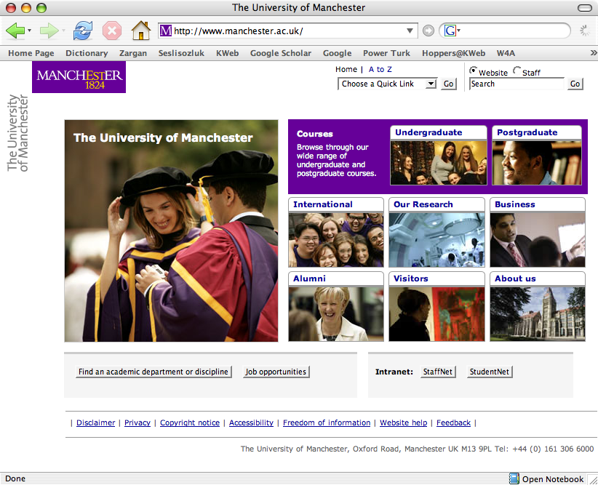

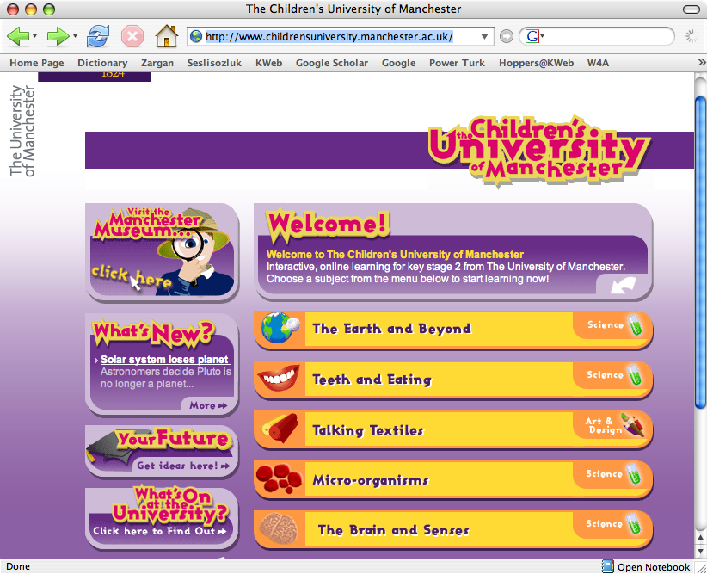
Figure 4 The children's University of Manchester
Figure 3 The home page of the University of Manchester

These two pages (Figure 3 and 4) clearly show how same kind of information could be rewritten for different user groups. If we would like to explain children what is Semantic Web then similar material has to be created and made publicly available.

Another area that we could look at is the dissemination of health information to public, for example we can look at how Health organizations explain infectious diseases to general public (see Figure 5). They particularly pay attention to the format and language used in the materials presented to general public. For example, scientific terms are simplified and simpler formatting is used for presenting complex data. Based on these case studies, a similar approach could be used on the Web portal. A subportal could be created to disseminate the information on the Knowledge Web portal to the general public.

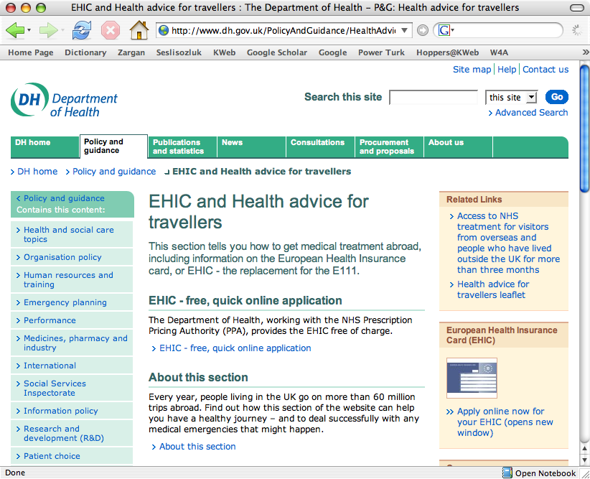
Figure 5 UK Department of Health

Publishing Articles for General Public
It is important that published materials are in journals or magazines that public could easily reach. Professional writers could be employed to write for local or national newspapers etc. The members of the network do not have the necessary skills to write for the general public.

A web site for the Computing Public
The web site of the project http://knowledgeweb.semanticweb.org is a project portal, not a dissemination site for our results. Attempting to find ANY results from the network is impossible unless you know the deliverable and work package structure, and even then it is difficult. Anyone wishing to use our results falls at the first hurdle. The whole site needs to be completely revised so that the results of the network are prominent and in a digestible form, that is: pithy web pages; succinct white papers and summaries; academic papers.

Supporting/Sponsoring Events Targeting General Public
As part of Gender Action plan, Hoppers@KWeb has sponsored the Career Development Workshop 2006. Events and activities like this are important for reaching the public. Knowledge Web could sponsor events like this to play important role in organizing these events and spreading information about Knowledge Web to the general public. In 2007 we need to do an audit of what public events we should be targeting.

Blogging the General Public and Computer Public
People read blogs. And plenty of people in the industry blog about the Semantic Web. For example:
- Dave Beckett’s WebLog page: http://journal.dajobe.org/journal/2003/07/semblogs/
- David McComb: http://semantic-conference.blogs.com/semtech06/
- Dan Zambonini:
- http://www.oreillynet.com/xml/blog/2006/06/the_7_flaws_of_the_semantic_we.html

Yet no Knowledge Web member actively blogs and we have no Knowledge Web blog. We recommend setting up RSS feeds and blogs for disseminating the articles we have written (see 1.4.2 and 1.4.3).

Organising Events that Involve General Public
Events could be organized in local schools, charities, and organizations to lecture general public about Semantic Web. However, this can be a great effort drain with potentially little impact, or only localized impact. We do not recommend this action.

Professional PR and Strategic Alliances
The WWW2006 conference demonstrated that it is possible to get the Semantic Web into the news and onto the pages of magazines, and hence to the general public. This was achieved by focusing around a significant event and significant professional public relations activity. Professional PR people know how to feed news stories. Given that Knowledge Web neither has the resources nor the know-how to engage with the media we recommend that it feeds organizations that do, and hence engages at “one step remove” from the public. Obvious alliances are:

- SemTech 2007 - THE place to learn about the commercialization of the Semantic Web - May 20-24, 2007, in San Jose, California http://www.semantic-conference.com/. This is a major industry activity and would attract media interest. In the past we have had little engagement.

- The Web Science Research Initiative (WSRI) http://www.webscience.org/ The Web Science Research Initiative (WSRI) is a joint endeavour between the Computer Science and Artificial Intelligence Laboratory (CSAIL) at MIT and the School of Electronics and Computer Science (ECS) at the University of Southampton. The goal of WSRI is to facilitate and produce the fundamental scientific advances necessary to inform the future design and use of the World Wide Web. It has a PR activity behind it we could leverage.

Source: Gender, Science and Technology for Sustainable Development (GenSciTech)
Source: Promoting Science Engineering and Technology for Women Unit (SET), Department of Trade and Industry, UK.
Hoppers@KWeb can be accessed at: http://hoppers-kweb.cs.manchester.ac.uk/.

